SANDERS MORRIS

Business Continuity Plan

November11.2023

Table of Contents
- Introduction 3
- Emergency Contact Persons 3
- Firm Policy 4
- BCP/SBD Organizational Structure 4
- SBD Notification Chart 5
- SBD Severity Levels 5
- Business Description 7
- Office Locations 7
- Alternative Physical Location of Employees 8
- Client Access to Funds and Securities 8
- Data Back-Up and Recovery (Hard Copy/Electronic) 8
- Financial and Operational Assessments 9
- Mission Critical Systems 10
- Alternate Communications with Clients, Employees, and Regulators 12
- Critical Business Constituents, Banks, and Counterparties 12
- Regulatory Reporting 13
- Disclosure of Business Continuity Plan 13
- Updates and Annual Review 14
- Senior Manager Approval 14
Appendix A – SBD Preparedness Checklist 14
Appendix B – BCP Report Following an SBD 15

Introduction
This Business Continuity Plan applies to Sanders Morris LLC (“SM”) and Tectonic Advisors, LLC (TA). SM is a broker/dealer and an investment adviser registered with the Securities and Exchange Commission (“SEC”) and is a member of the Financial Industry Regulatory Authority (“FINRA”). TA is a SEC registered investment adviser and affiliate of SM.

This Business Continuity Plan was prepared and is maintained to address the requirements under applicable SEC and FINRA Rules. As TA may rely on SM for compliance and other forms of support, this plan addresses all entities and will be collectively referred to hereafter as “the Firm.”

Emergencies can occur at any time, without warning. Careful planning can help personnel handle crises and emergencies with appropriate responses. Business unit managers are responsible for ensuring that they are familiar with this Business Continuity Plan (BCP) and have any ancillary emergency plans in place for their businesses. To aid managers in preparation, a Significant Business Disruption Preparedness Checklist is attached as Appendix A.

Emergency Contact Persons
The two emergency contact persons listed in the FINRA Contact System (FCS) for SM are:

George L. Ball Chairman  Sanders Morris LLC 600 Travis Street, Suite 5900  Houston, Texas 77002  Office: 713.250.4280  Cell: 713.560.9363  Fax: 713.250.4297  george.ball@SMgroup.com | Steve Mangold  Chief Executive Officer and Chief Compliance Officer Sanders Morris LLC  600 Travis Street, Suite 5900  Houston, Texas 77002  Office: 713.250.4222  Cell: 713.206.7032  Fax: 713.250.4297  steve.mangold@SMgroup.com

These contacts will be updated in the event of a material change, and our BCP Coordinators will review them annually.

Additionally, the following employees are members of the Firm’s Significant Business Disruption (SBD) Management Team.

 | Work | Cell | Email
SM Houston
Adrienne Montilla | 713.250.4281 | 832.216.1949 | Adrienne.montilla@SMgroup.com
David Block | 713.220.5100 | 512.585.2170 | david.block@SMgroup.com
SM Dallas
Nancy Dixon | 972.398.4608 | 214.725.8189 | nancy.dixon@SMgroup.com
Erick Kuebler | 972.398.4607 | 214.632.2048 | erick.kuebler@SMgroup.com
Chris Pittman | 972.398.4604 | 817.946.8162 | chris.pittman@SMgroup.com
Tectonic Houston
A. Haag Sherman | 713.250.4210 | 713.569.8483 | hsherman@tectonicadvisors.com
Tectonic Plano
Michelle Baird | 469.298.4108 | 972.467.0048 | mbaird@tectonicadvisors.com
Paul Lyons | 972.764.6520 | 972.979.0703 | plyons@tectonicadvisors.com
Brad Sanders | 972.764.6521 | 214.497.5051 | bsanders@tectonicadvisors.com

Firm Policy
The Firm’s policy is to respond to a Significant Business Disruption (“SBD”) by safeguarding employees’ lives and firm property, making a financial and operational assessment, quickly recovering and resuming operations, protecting all of the firm’s books and records, and allowing our clients to transact business. In the event that we determine we are unable to continue our business, we will assure clients prompt access to their funds and securities.

Significant Business Disruptions (SBDs)
Our plan anticipates two kinds of SBDs, internal and external. Internal SBDs affect only our firm’s ability to communicate and do business, such as a fire in one of our buildings. External SBDs prevent the operation of the securities markets or a number of firms, such as a terrorist attack, a city flood, or a wide-scale, regional disruption. Our response to an external SBD relies more heavily on other organizations and systems, especially on the capabilities of our clearing firm.

BCP Approval and Execution Authority
George L. Ball, Chief Executive Officer of SM, a registered principal, is responsible for approving the BCP and for overseeing the performance of the required annual review. The BCP Coordinators, Adrienne Montila and Nancy Dixon, have the authority to execute this BCP.

BCP Location and Access
The Firm will maintain copies of its BCP and the annual reviews, and the changes that have been made to it for inspection. A complete copy of the BCP will be made accessible to all employees.

BCP/SBD Organizational Structure
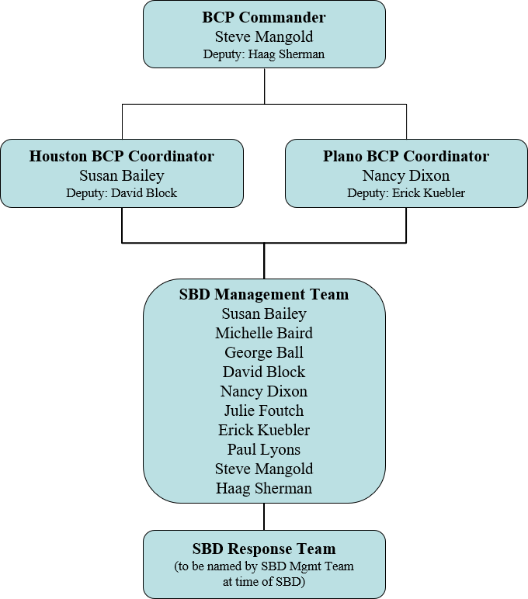

The BCP Coordinator has overall responsibility to carry out the BCP action plan determined by SBD Management Team. He/she will:

  - Interface with SBD Response Team.
  - Obtain necessary authorizations and resources from BCP Commander and SBD Management Team.
  - Make recommendations regarding business resumption for the location.
  - Communicate with other offices and personnel as needed.
  - Address staffing requirements.
  - Provide overall leadership to the SBD Response Team.
  - Periodically update SBD Management Team.

SBD Notification Chart
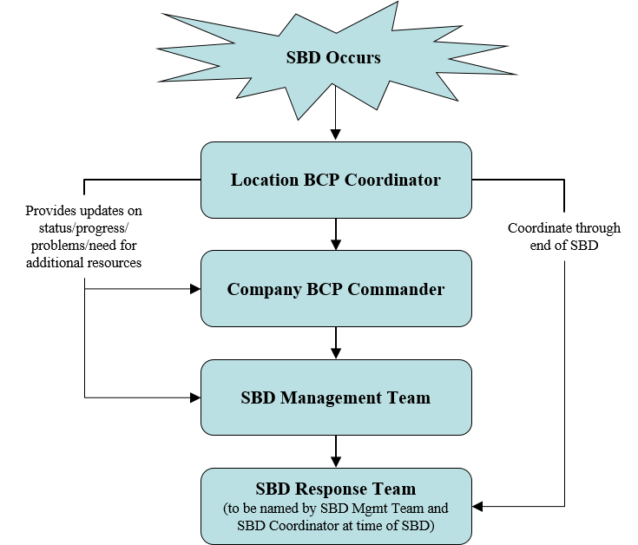

SBD Severity Levels
All SBDs are assigned a severity level by the BCP Commander/BCP Coordinator, in conjunction with the SBD Management Team, if necessary. Example conditions of each severity level and the accompanying actions/effects follow.

For Level 3 and 4 SBDs, the BCP Coordinator will complete a BCP Report Following an SBD to help ensure preparedness for future SBDs (see Appendix B).

 | Example Conditions | Actions | Effects
Normal Operations | - Continuing activity throughout the year. | - All managers and employees assigned to responsibilities for hurricane/severe weather and emergency planning and implementation are required to assess, review, and prepare plans to ensure  a constant state of readiness. | - No effects.
Level 1 | - Fire alarm sounds (no confirmed fire, smoke, or service interruption)  - Utility failure (minor impact or service interruption).  - Severe weather watch/warning.  - Tropical storm or hurricane  enters coastal area (storm is more than 48 hours away). | - Localized actions may be required.  - Actions may be restricted to an area or department or group. | - There is no significant effect.  - No disruption of function.  - Very little damage.  - No apparent threat to personal safety.
Level 2 | - Utility failure – impact limited to one department or location.  - High probability of severe weather.  - Hurricane watch for coastal area is issued (storm is 48 hours away). | - Business as usual; all personnel report to work.  - Localized actions may be required.  - Actions may be restricted to an area or department or group. | - There is no significant effect.  - No disruption of function.  - Very little damage.  - No apparent threat to personal safety.
Level 3 | - Minor fire.  - Severe weather threatening.  - Hurricane warning for coastal area is issued (storm is less than 48 hours away).  - Substantiated threat or event (involving terrorism, etc.).  - Significant internet outage  - Denial of Service attack or computer virus outbreak. | - SBD Emergency Management Team will convene.  - Non-essential staff may be released from work or may not report to work. | - Business is disrupted.  - Facilities/utilities damaged.  - Threat to personnel safety exists.
Level 4 | - Major Fire.  - Major structural damage or failure.  - Significant severe weather/ storm damage has occurred.  - Severe emergency conditions.  - Event involving terrorism.  - Pandemic-building closed | - SBD Emergency Management Team will convene to determine action. | - Business is severely disrupted.  - Facilities/utilities severely damaged.  - Threat to personnel safety exists.

Business Description
The Firm provides a broad range of financial services including institutional, retail brokerage, financial advisory, asset management, financial planning, investment banking and engages in private placements. We are an introducing firm and do not perform any type of clearing function for ourselves or for others. Furthermore, we do not hold client funds or securities. We accept and enter orders. All transactions are sent to our clearing firm, which executes our orders, compares them, allocates them, clears and settles them. Our clearing firm also maintains our clients’ accounts, can grant clients access to them, and deliver funds and securities. The Firm services retail and institutional clients.

The Firm utilizes various clearing firms to conduct business. Contact information for each clearing firm is listed as follows:

Clearing Firm | Contact Person | Alternative Contact
Pershing | Kelly Delgado  Global Client Relationships-Account Management  www.pershing.com Work: 415.778.1908  Fax: 201-413-2800  kelly.delgado@pershing.com | Marc Galgano Vice President  Global Client Relationships Pershing www.pershing.com  One Pershing Plaza Jersey City, NJ 07399 Work: 321.249.4091  mgalgano@pershing.com
TD Ameritrade | CoreEast4 Team TD Ameritrade  7801 Mesquite Bend Drive, Suite 112  Irving, TX 75063  Work: 800.400.6288 or 888.354.8361  Coreeast4@TDAmeritrade.com www.tdameritrade.com

Office Locations

Office |  | Office Type | Supervisor | Travel to via | Activity/ Mission Critical Systems
1 | Sanders Morris LLC  (Headquarters)  600 Travis Street, Suite 5900  Houston, Texas 77002  713.224.3100 | OSJ  B/D IA | Steve Mangold / David Block | Bus Car Foot | Order taking and entry; institutional sales and trading, investment banking using NASDAQ, Bloomberg, Pershing  NetX360; QUODD, FlexTrade, FactSet, WINOPS, Schwab
2 | Sanders Morris LLC 5950 Sherry Lane, Suite 470  Plano, TX 75225  972.398.4640 | OSJ  B/D IA | Nancy Dixon | Bus Car Foot | Order taking and entry; institutional sales and trading, operations and client services, investment banking using, Bloomberg, Pershing NetX360;  QUODD, Flextrade, Oasys/CTM
3 | Tectonic Advisors, LLC  600 Travis Street, 59th Floor Houston, Texas 77002  713.224.3100 | IA | Haag Sherman | Bus Car Foot | Order taking and entry; operations and client services, investment banking using TD  Ameritrade

Office |  | Office Type | Supervisor | Travel to via | Activity/ Mission Critical Systems
4 | Tectonic Advisors  6900 Dallas Parkway, Ste 625  Plano, TX 75024  972.398.4640 | IA | Michelle Baird | Bus Car Foot | Order taking and entry; operations and client services, investment banking using TD Ameritrade  Accounting reporting using Microsoft Dynamics, Jet Reporting (in conjunction with Microsoft Dynamics), Pershing NetX 360, CoAdvantage Online Payroll, CCH Prosystem FX tax software (through CWA), Orion, Adobe, MS Office suite (functions are heavily dependent upon Excel), Expense reporting  through Expensify; Outlook for email, Zoom, Zoho

Alternative Physical Location of Employees
In the event of an SBD, employees in all offices have the ability to work from home via secure virtual workstations or web-based programs with built-in security and sophisticated user entitlements. If necessary, we will move our staff from affected offices to the closest of our unaffected office locations. Additionally, employees in each location have the ability to temporarily support functions required at another location.

Client Access to Funds and Securities
The Firm does not maintain custody of clients’ funds or securities, which are maintained at one of our clearing firms. In the event of an internal or external SBD, if telephone service is available, our registered persons will take client orders or instructions and contact our clearing firm on their behalf. If our registered persons do not have telephone access, and our internet access is available, our firm will post on our website that clients may access their funds and securities by contacting the clearing firm which holds their assets. The firm will identify the name and contact information of the clearing firms and make this information available to all clients through its disclosure policy.

If SIPC determines that we are unable to meet our obligations to our clients or if our liabilities exceed our assets in violation of Securities Exchange Act Rule 15c3-1, SIPC may seek to appoint a trustee to disburse our assets to clients. We will assist SIPC and the trustee by providing our books and records identifying client accounts subject to SIPC regulation.

Data Back-Up and Recovery (Hard Copy/Electronic)
The Firm maintains hard copy client books and records, as well as electronic copies.

Clients Of | Maintenance of  Hard Copy Books and Records | Maintenance of Electronic Records
SM Houston | Stored at:  600 Travis, Suite 5900  Houston, Texas 77002  Managed by:  David Block, Operations Manager 713.226.4808 | T Bank, an affiliated company that serves as our IT support provider, is responsible for the storage and maintenance of electronic records Managed by:  Thad Hutcheson, CIO/CTO 972.720.9005

SM Dallas | Stored at:  5950 Sherry Lane, Suite 470  Dallas, TX 75024  Managed by:  Nancy Dixon, Operations Manager 972.398.4608 | T Bank, an affiliated company that serves as our IT support provider, is responsible for the storage and maintenance of electronic records Managed by:  Thad Hutcheson, CIO/CTO 972.720.9005
TA Houston TA Plano | Stored at:  6900 N. Dallas Parkway Suite 625, Plano TX 75024 Managed by:  Michelle Baird 469.298.4108 | T Bank, an affiliated company that serves as our IT support provider, is responsible for the storage and maintenance of electronic records Managed by:  Thad Hutcheson, CIO/CTO 972.720.9005

The Firm maintains the following document types and forms that are not always transmitted to our clearing firm:

- New account forms
- Cash agreements
- W-9 forms

Back-up Hard Copy Book and Electronic Client Records
The Firm stores hard copy records electronically by scanning and storing them on our network drive/server, along with other electronic records. Network drives/servers are backed up daily and kept in a secure location.

Drive/Server | Back-up Process | Back-up Storage Location
SM Dallas SM Houston TA Houston TA Plano | Network servers perform a daily offsite back-up. Retention plans are configured to keep snapshots of daily and monthly back-ups.  Managed by:  Thad Hutcheson, T Bank CIO/CTO 972.720.9005 | T Bank, an affiliated company that serves as our IT support provider, manages and can access our back- up electronic records  Managed by:  Thad Hutcheson, CIO/CTO 972.720.9005

In the event of an internal or external SBD that causes the loss of our paper records, we will electronically recover them from our back-up site. If one of our sites is inoperable, we will continue operations from our back-up site or an alternate location. For the loss of electronic records, we will electronically recover data from our back-up site, or, if one of our sites is inoperable, continue operations from our back-up site or an alternate location.

Financial and Operational Assessments

Operational Risk
In the event of an SBD, we will immediately identify what means will permit us to communicate with our clients, employees, critical business constituents, critical banks, critical counterparties, and regulators. Although the effects of an SBD will determine the means of alternative communication, the communications options we will employ will include our website, cellular telephones, telephone voice mail, secure e-mail and mail/delivery services. In addition, we will retrieve our key activity records as described in the section above, Data Back-Up and Recovery (Hard Copy and Electronic).

Financial and Credit Risk
In the event of an SBD, we will determine the value and liquidity of our investments and other assets to evaluate our ability to continue to fund our operations and remain in capital compliance. We will contact our clearing firms, critical banks, and investors to apprise them of our financial status. If we determine that we may be unable to meet our obligations to those counterparties or otherwise continue to fund our operations, we will request additional financing from our bank or other credit sources to fulfill our obligations to our clients. If we cannot remedy a capital deficiency,

we will file appropriate notices with our regulators and immediately take appropriate actions as directed by our regulators. Such actions range from no action for the first offense, to payment of fines by the firm and/or responsible individuals for multiple offenses and to suspension of the firm to perform one or more aspects of its business for consistent capital violations.

Mission Critical Systems
The Firm’s “mission critical systems” are those that ensure prompt and accurate processing of securities transactions, including order taking, entry, execution comparison, allocation, clearance and settlement of securities transactions, the maintenance of client accounts, access to client accounts, and the delivery of funds and securities. More specifically, these systems include:

SM Systems | Purpose/Function
Bloomberg | News information system as well as an execution tool; communication device for international clients.
FlexTrade | Order Management System supports equity trade routing to the various markets, listed, OTC and 3rd Party. Also enables direct connection to many of our buy side clients thru FIX platforms.
NetX360 | Internet based on-line trading vehicle that routes either directly to Pershing for execution or to LAVA for execution by SM Market Makers.
CoAdvantage Online Payroll | Internet based payroll system.
QUODD | Quote system real time quotes, time and sales, etc.
Schwab | Internet based system on-line trading that goes directly to Schwab for execution. Account information on clients of RIA.
WINOPS | Commission processing system used by accounting and partners. Data is stored in a database format on a Houston server.
Communications via email | Trades are not processed via email, but it is the most used communication mechanism within the Firm.
OASYS/CTM | Service platform that helps buy side firms and broker/dealers efficiently match and confirm trade details, to increase transparency and to mitigate risk.
FactSet | Research system providing computer-based financial data and analysis.
Tectonic Systems | Purpose/Function
CoAdvantage Online Payroll | Internet based payroll system.
Pershing NetX360 | Internet based on-line trading vehicle that reroutes either directly to Pershing for execution or to LAVA for execution by TA Market Makers.
TD Ameritrade - Veo | Internet based on-line trading vehicle that routes directly to TD Ameritrade
Microsoft Dynamics | CRM and ERP capabilities, integrating data, business logic, and processes.
JetReports | Reporting, analytics, and budgeting solutions used in conjunction with Microsoft Dynamics.
Orion | Portfolio management software
CCH Prosystem FX | Allows automated tax returns processes as well as tax compliance and preparation  solutions.
MS Office Suite | Word processing, excel spreadsheets, email communications
Expensify | On-line expense reporting
Communications via email | Trades are not processed via email, but it is the most used communication mechanism within the Firm.

We have primary responsibility for establishing and maintaining our business relationships with our clients and have sole responsibility for our mission critical functions of order taking, entry and ensuring proper execution. Our clearing firms provide through contract, order routing, execution, comparison, allocation, clearance and settlement of securities transactions, the maintenance of client accounts, access to client accounts and the delivery of funds and securities.

All contracts with our clearing firms provide that the clearing firm will maintain a business continuity plan and the capacity to execute that plan. Our clearing firms represent to us that that they will advise us of any material changes to their plans that might affect our ability to maintain our business and have presented us with an executive summary of their plans, which are attached. In the event one of our clearing firms executes its plan, it represents that it will notify us of such execution and provide us equal access to services as its other clients. If we reasonably determine that one of our clearing firms has not or cannot put its plan in place quickly enough to meet our needs or is otherwise unable to provide access to such services, our clearing firms represent to us that they will assist us in seeking services from an alternative source.

Our clearing firms represent that they back up our records at remote, out of region sites. They represent that they operate back-up operating facilities in geographically separate areas with the capability to conduct the same volume of business as their primary sites. Our clearing firms have also confirmed the effectiveness of their back-up arrangements to recover from a wide scale disruption by testing on a regular basis. Pershing stated that their disaster recovery capabilities are aggressively tested on a quarterly basis. First Clearing stated their business continuity plan is reviewed, updated and tested, at a minimum, on an annual basis and they conduct periodical testing of their back- up capabilities.

Recovery time objectives provide concrete goals to plan for and test against. They are not, however, hard and fast deadlines that must be met in every emergency situation, and various external factors surrounding a disruption, such as time of day, scope of disruption, and status of critical infrastructure – particularly telecommunications – can affect actual recovery times. Recovery refers to the restoration of clearing and settlement activities and after a wide-scale disruption; resumption refers to the capacity to accept and process new transactions and payments after a wide-scale disruption. Our clearing firms have the following SBD recovery time and resumption objectives:

Pershing | operational in less than four hours
TD Ameritrade | immediate switch over to a backup site – no down time

The Firm’s Mission Critical Systems
Order Taking
Currently, our firm receives orders from clients via telephone/FIX connection/fax/email/in person visits by the client. During an SBD, either internal or external, we will continue to take orders through any of these methods that are available and reliable, and in addition, as communications permit, we will inform our clients when communications become available to tell them what alternatives they have to send their orders to us. Clients will be informed of alternatives by notices posted on our website or contact through cellular telephones. If necessary, we will advise our clients to place orders directly with the clearing firm handling their accounts.

Order Entry
Currently, our firm at times still enters orders by recording them on paper and telephoning the order into a trading desk. More often though orders are added to one of our electronic or Order Management Systems, or electronically and by sending them to one of our clearing firms thru their front end trading platforms. Alternatively, we place client orders through direct systems which provide access to exchanges, such as Instinet, NASAQ Workstation and LAVA if there is a failure in our clearing firms’ systems. We also have the ability to directly phone NYSE floor brokers and traders at our clearing firms as well as traders at other broker dealers.

In the event of an internal SBD, we will enter and send records to our clearing firm by the fastest alternative means available, which includes cellular telephone, email from an alternate location and overnight delivery of paper records to the clearing firm. In the event of an external SBD, we will maintain the order in electronic or paper format, and deliver the order to the clearing firm by the fastest means available when it resumes operations. In addition, during an internal SBD, we may need to refer our clients to deal directly with the clearing firm for order entry.

Order Execution
We currently route orders to our clearing firms or by using direct systems such as Instinet, NASDAQ Workstation and LAVA. In the event of an internal SBD, order execution would be handled by employees located at an alternative

site. In the event of an external SBD, we would utilize direct systems such as Instinet, NASDAQ Workstation and LAVA and/or telephone NYSE floor brokers, traders at clearing firms or traders at other broker dealers.

Other Services Currently Provided to Clients
In addition to those services listed above in this section we also process client requests for checks and wiring of funds from their accounts. In the event of an internal SBD, these requests would be processed through alternative office sites. In the event of an external SBD, our clearing firms have assured us all client requests would be processed expediently due to their short recovery period.

Mission Critical Systems Provided by Our Clearing Firms
The Firm relies, by contract, on our clearing firms to provide order routing and execution, order comparison, order allocation, and the maintenance of client accounts, delivery of funds and securities, and access to client accounts.

Alternate Communications with Clients, Employees, and Regulators

Clients
We now communicate with our clients using the telephone, e-mail, instant messaging, our website, fax, delivery services, U.S. mail, and in person visits at our firm or at the other’s location. In the event of an SBD, we will assess which means of communication are still available to us and use the means closest in speed and form (written or oral) to the means that we have used in the past to communicate with the other party. For example, if we have communicated with a party by email but the internet is unavailable, we will call them on the telephone and follow up where a record is needed with paper copy in the U.S. mail.

Employees
We now communicate with our employees using telephone, e-mail, and in person. In the event of an SBD, the BCP Coordinator will assess which means of communication are still available to us and use the means closest in speed and form (written or oral) to the means that we have used in the past to communicate with the other party. We will also employ a call tree that includes all employee cell phone numbers so that the BCP Coordinator can reach all employees quickly during an SBD, whether during work or after hours.

The following BCP Coordinators will invoke use of the call tree as needed:

 | Work | Cell | Email
Adrienne Montila | 713.220.5115 | 832.928.0607 | susan.bailey@SMgroup.com
Michelle Baird | 469.298.4108 | 972.467.0048 | mbaird@tectonicadvisors.com
Nancy Dixon | 972.398.4608 | 214.725.8189 | nancy.dixon@SMgroup.com

Regulators
We are currently members of FINRA, NASDAQ and NYSE-ARCA. We are also subject to the rules and regulations of the Securities & Exchange Commission and the Municipal Securities Rulemaking Board. We communicate with our regulators using the telephone, e-mail, fax, U.S. mail, and in person. In the event of an SBD, we will assess which means of communication are still available to us and use the means closest in speed and form (written or oral) to the means that we have used in the past to communicate with the other party.

Critical Business Constituents, Banks, and Counterparties

Business Constituents
We have contacted our critical business constituents (business with which we have an ongoing commercial relationship in support of our operating activities, such as vendors providing us critical services), and determined the extent to which we can continue our business relationship with them in light of the internal or external SBD. We will quickly establish alternative arrangements if a business constituent can no longer provide the needed goods or services when we need them because of an SBD to them or our firm. Our major suppliers are:

Service/Product | Vendor | Address and Phone Number
Accounting Software | Microsoft Dynamics | Microsoft Dynamics
Payroll Services | CoAdvantage  Acct Mgr.: Sher Morden | 350 Buschwood Park Drive, Suite 200  Tampa, FL 33618  888.925.2990
Property Insurance | First Texas Insurance Attn: Bob Walch | 700 Highlander, Ste 350  Arlington, TX 76015  817.275.2626 or 800.367.4073 ext. 109

Banks
The Firm has contacted its banks and lenders to determine if they can continue to provide the financing that we will need in light of the internal or external SBD. The banks maintaining the Firm’s operating accounts are as follows:

Sanders Morris LLC | T Bank, NA  16200 Dallas Parkway, Suite 190  Dallas, TX 75248  972.720.9000
Tectonic Advisors, LLC | T Bank, NA  16200 Dallas Parkway, Suite 190  Dallas, TX 75248  972.720.9000
Tectonic Financial, Inc.  (parent company of all of the above) | T Bank, NA  16200 Dallas Parkway, Suite 190  Dallas, TX 75248  972.720.9000

Counterparties
We have sent a copy of our BCP Disclosure Statement to our counterparties whom we consider our critical counterparties and have received copies of their BCP Disclosure Statement. Our Statement provides contact information for our clearing firms so that in the event pending transactions cannot be completed, our counterparties can work with T Bank directly to make alternative arrangements to complete all transactions as soon as possible.

Regulatory Reporting
Our firm is subject to regulation by: FINRA and the SEC. We now file reports with our regulators using paper copies in the U.S. mail, and electronically using fax, e-mail, and the internet. In the event of an SBD, we will check with the SEC, FINRA and other regulators to determine which means of filing are still available to us, and use the means closest in speed and form (written or oral) to our previous filing method. In the event that we cannot contact our regulators, we will continue to file required reports using the communication means available to us.

Financial Industry Regulatory Authority New Orleans District Office
1100 Poydras Street, Energy Centre, Suite 1050 New Orleans, LA 70163
Attn: Brady G. Perniciaro, Principal Regulatory Coordinator Phone: 504.522.6527

Disclosure of Business Continuity Plan
The Firm’s New Account Form contains a BCP disclosure statement in the Client Agreement section. We may also post the disclosure statement on the home pages of the Firm’s websites (www.SMgroup.com, or www.tectonicadvisors.com) and mail it to clients upon request.

Updates and Annual Review
The Firm will update this plan whenever we have a material change to our operations, structure, business or location or to those of our clearing firms. In addition, our firm will review this BCP annually to modify it for any changes in our operations, structure, business, or location or those of our clearing firm.

Senior Manager Approval
I have approved this Business Continuity Plan as reasonably designed to enable our firm to meet its obligations to clients in the event of an SBD.

Signed: Steve Mangold
Chief Executive Officer

Date: June 1, 2023

A P P E N D I X A

SBD Preparedness Checklist

Business Unit:
Manager:
Who will serve as your SBD Deputy Commander?
How many locations does your business unit have?
For each location, who will serve as Location SBD Commander?
Y | N
 | Business Continuity Plan
 | Has each commander been given a copy of the Firm’s Business Continuity Plan (BCP)?
 | Is each commander able to access a copy of the BCP, call trees, and anything else they may need during an SBD if his/her office/computer is inaccessible?
 | Alternative Work Locations
 | Should your building be closed, do you know how to monitor building status?
 | Do you know what locations your critical personnel could relocate to and work from?
 | Could your critical personnel work from home?
 | Employees
 | Do you know how – and how often – you would keep your employees informed during an SBD?
 | Is your business unit emergency call tree current?
 | Do you have alternate non-work email addresses for all of your employees?
 | Phones
If you are unable to access your office, but power remains on, do you know how to forward your phones
remotely?
Have your employees been given instructions how to access the phone system remotely to forward lines,
check voice mail, and/or record disaster related messages?
 | If phones and email services are generally unavailable, do you know how to contact local radio stations or television stations to distribute messages?
 | Computers
 | Have your employees been given instructions how to access email remotely?
 | Do your critical personnel have access to home computers or laptops?
 | Do your critical personnel have VPN access to simulate their desktop on a remote computer?
 | Is the software on remote computers up to date to facilitate use when logging into VPN?
Can you prioritize your computer systems, applications, services and other business functions into a
preferred recovery sequence?
 | Do you understand recovery time is usually one day?
 | Is this acceptable for your systems?
 | Do you understand the recovery point is usually one day?
 | Is this acceptable for your systems?
 | Documents
 | Do you forward all original client documents to home office for storage?
 | Have all documents or files critical to your business been imaged?
 | Clients
 | Do you know how you would keep your clients informed during an SBD?
 | Do you know where to direct your clients for updates/information during an SBD?

Business Continuity Plan (BCP) Report Following Significant Business Disruption (SBD)

SBD Start Date/Time:
SBD End Date/Time:
SBD
Internal/External:
SBD Description:
Site Location:
Address:
Employee Impact:
Asset Impact:
Client Impact:
Building Impact:
Other Impact(s):
Time Help Desk Notified:
Time Management Notified:
Action Plan/Response:
Problems/Issues Encountered:
What went right?
What could have been done better?
IT Services Evaluation:
BCP Evaluation:
Post Event Analysis Prepared by:

